WOMEN’S LUNCHEON

Hello, women of Messiah! I hope you are all enjoying spring as we move from autumn to winter in the southern hemisphere. The weather is finally beginning to cool, and the rain is bringing a much-needed drink of water for the plants and animals surrounding. As I look to my final two months in this gorgeous country, there is so much to reflect upon my year. I don’t even know where to begin, and I surely do not know where to end, so I suppose I’ll just jump in!

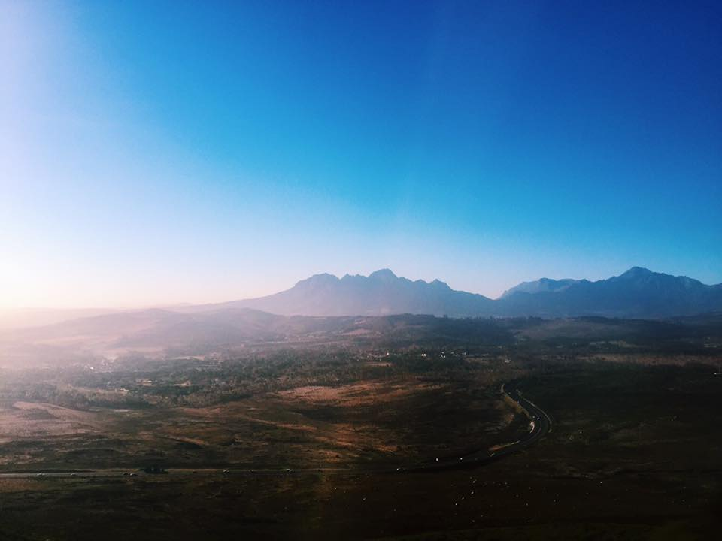

This year, I have been participating in a program called “Young Adults in Global Mission” (or YAGM as we like to call it) through the ELCA. This program supports about 80-90 young adults ages 21-29 as they pursue a year of international service and volunteer work in one of numerous countries around the world. The YAGM program places each young adult where they see fit in countries in South America, Europe, Southeast Asia, Australia, and Africa. Each year of service is completely different from the next.

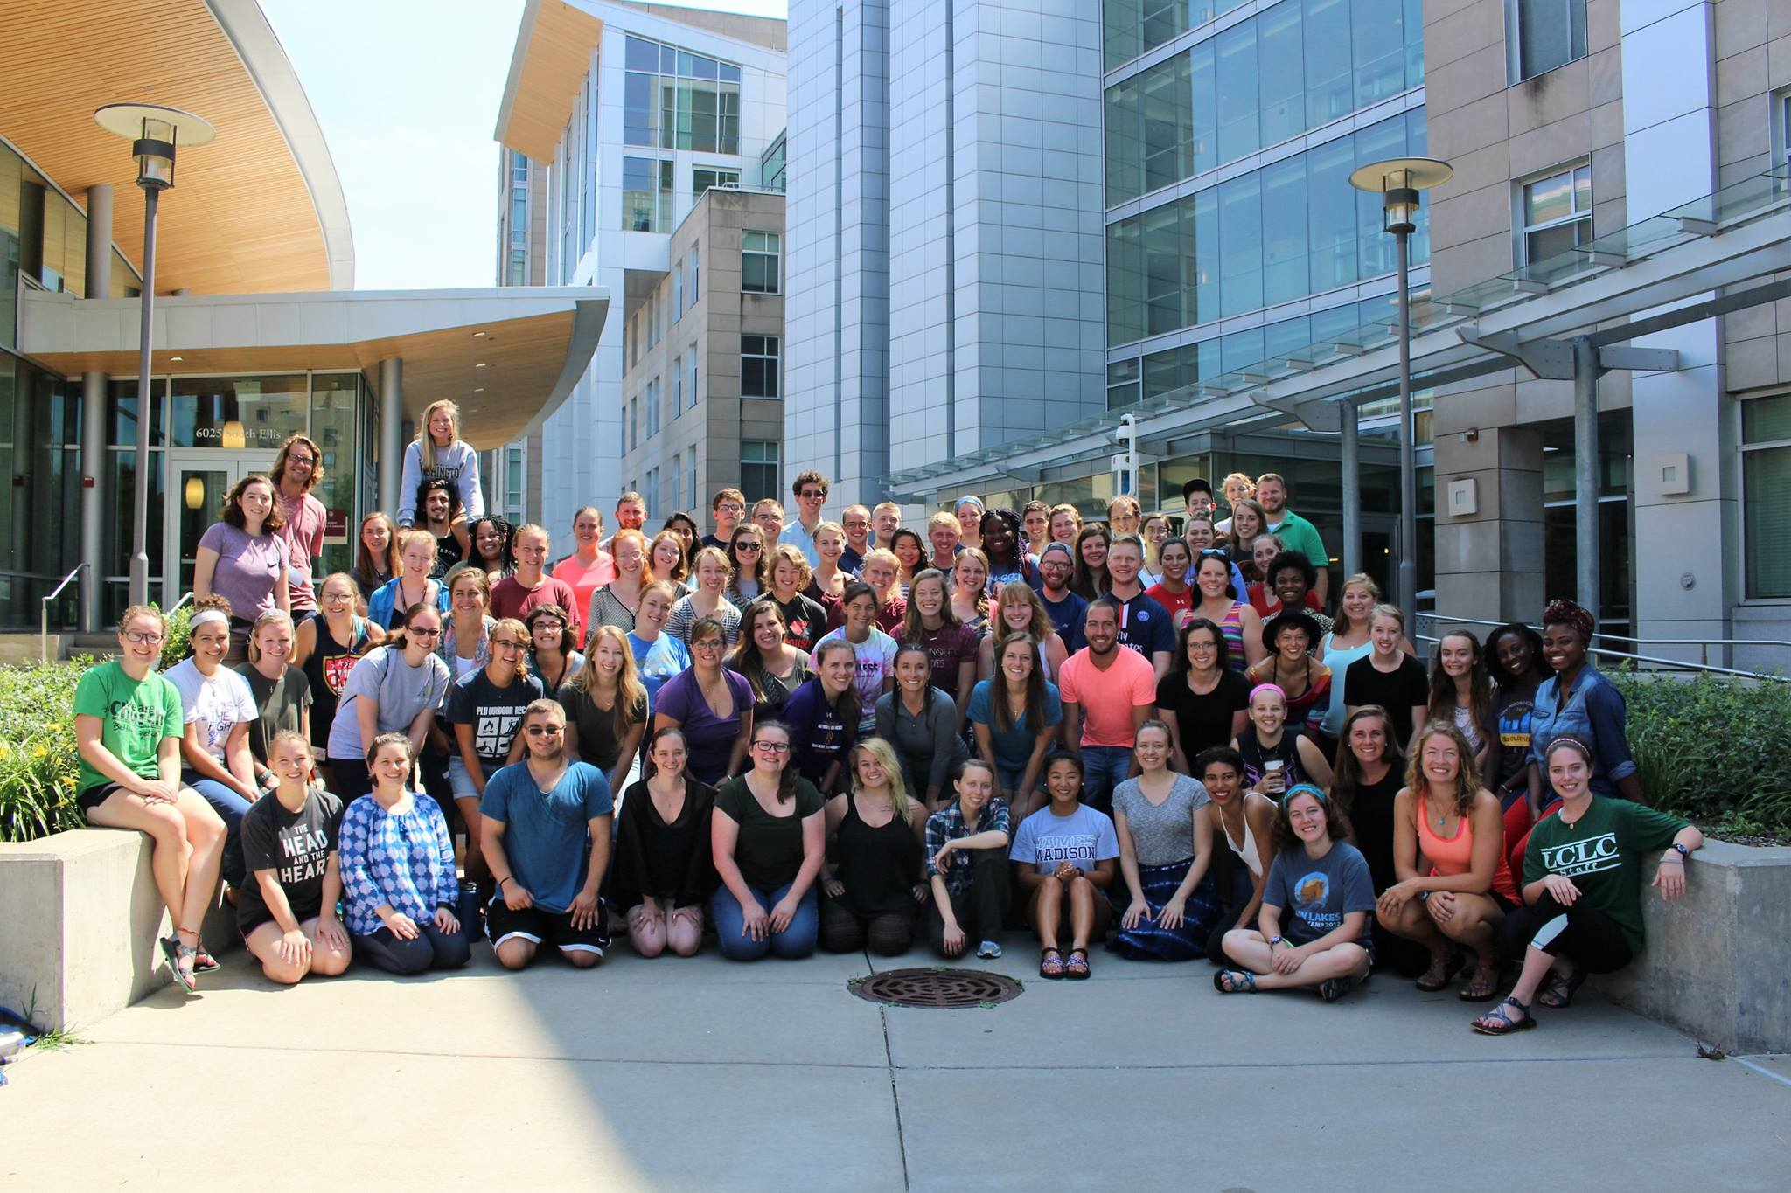

This program is rooted in the practice of accompaniment – walking side by side with our brothers and sisters on equal ground. What can we learn from each other? What stories need to be heard? This is a practice of “being” and not “doing” – a focus on building relationships rather than building actual structures. This is why I fell in love with the program. Each volunteer works in their community learning about and confronting privilege, economic disparities, racial injustices, the devastative effects of colonialism, and seeks to build lasting relationships, families, and friends around them.

Last August, I packed up and left Washington for the year to move to the country of South Africa. This country is given the name, “the Rainbow Nation.” This refers to the multitude of cultures, peoples, and languages that make up the republic. There are 11 official national languages, just to give a taste of the countless cultures. In 1994, South Africa held its first democratic elections, and elected Nelson Mandela as the president of their country – and also ended Apartheid. Apartheid is a word for segregation, and in context referred to the forced resettlement, enslavement, and legal segregation of the black population of the country – whom also happened to make up the majority of the population. There is so much more that goes into the history of South Africa, but this just gives a taste. The wounds of Apartheid are still fresh, and each day I hear stories and see the impacts of this devastating history. I see reflections of the civil rights movement in the US, and I see the strength of a population who had their own sort of resurrection so recently.

Within the country, I am living in the province of KwaZulu-Natal. I am living in the township Ngwelezane, near the town Empangeni. The dominant language and culture in the area, is of the Zulu people. I have been (slowly) learning some conversational isiZulu, and learning more and more about the culture of the Zulu people. I live with a host family – a young female Reverend named Mbali, and her niece, Yenzi. The three of us live in a parsonage of one of the many Lutheran congregations in the area. I spend many of my days attending church functions with Mbali, helping her with schoolwork (she’s working on a Masters degree in Gender, Religion, and Health), and assisting with church needs in the area.
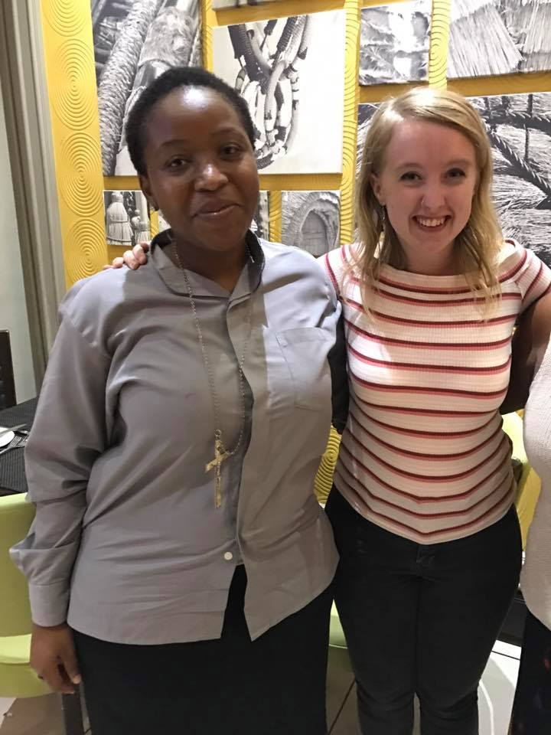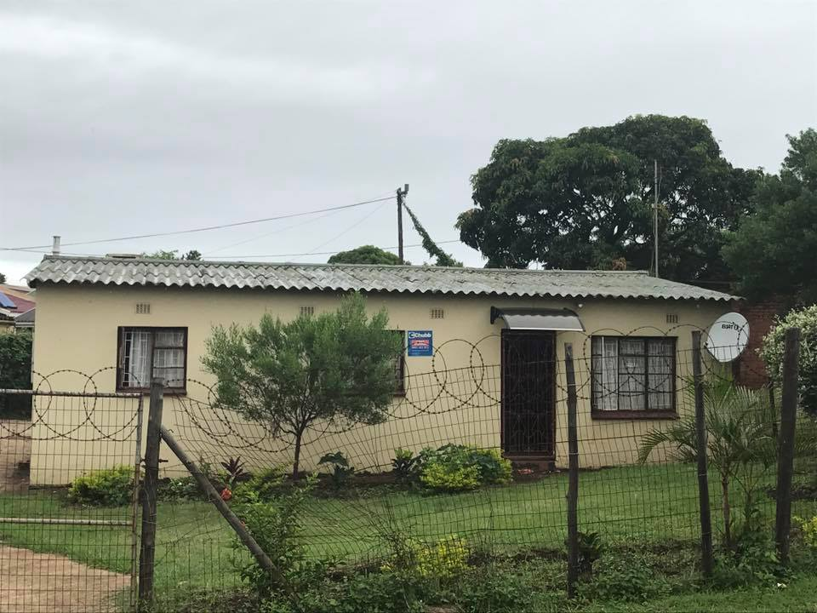

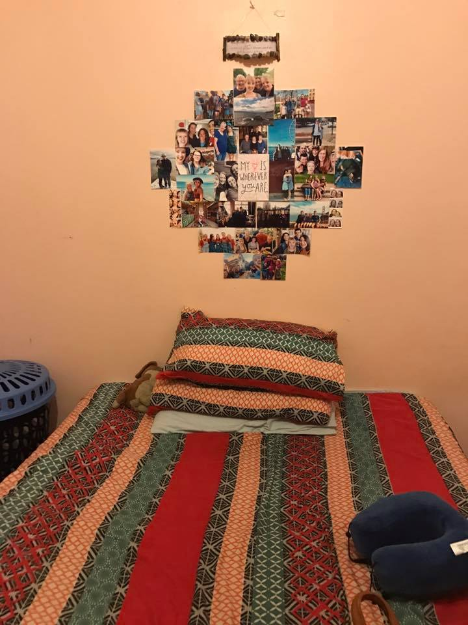

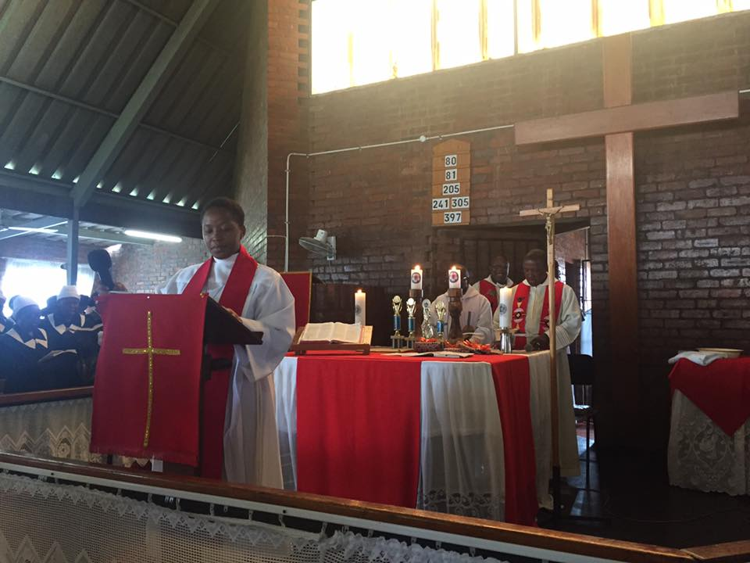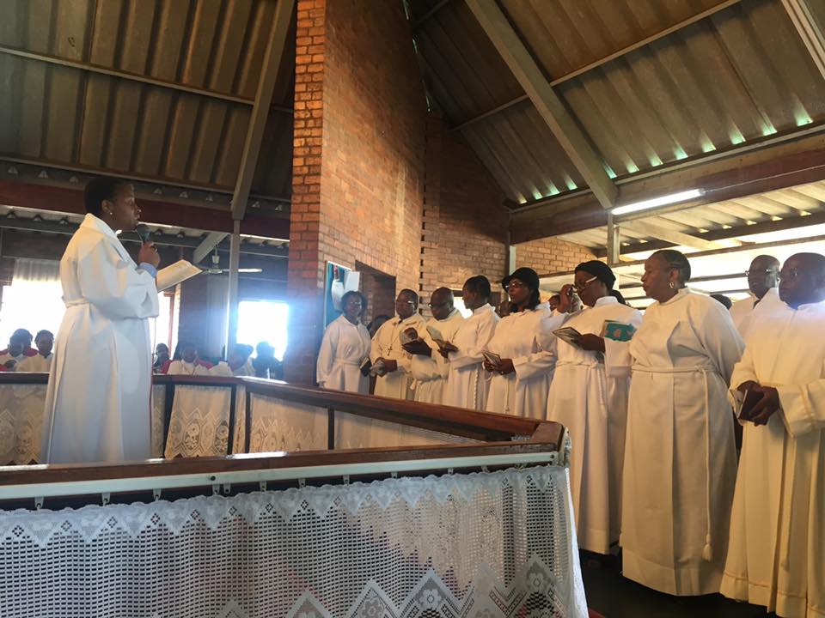

I spend three or four days a week volunteering with the Ngwelezane Place of Safety. This is a center for children and youth who have been orphaned, abandoned, abused, or neglected. It’s a short-term boarding school and activity center for children as they wait to get placed with new families, long-term homes, or get reunited with their families. I work primarily with the social workers, as many of the kids do not speak English and thus communication is a bit difficult. I still get to color with them and play games in the office as they wait through meetings. Otherwise I do a lot of administrative activities, and assist a lot with typing, filing, copying, and organizing. The social workers and teachers have been beyond sweet to me. I am so grateful and in awe of the work they do and the love they give each and every day.

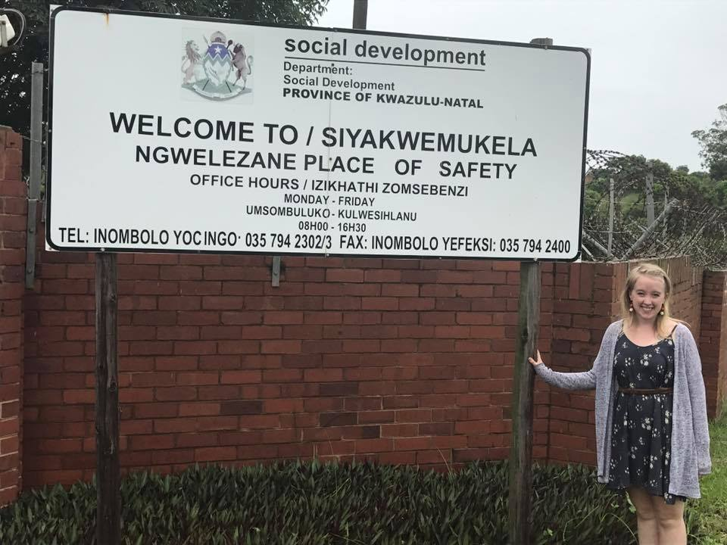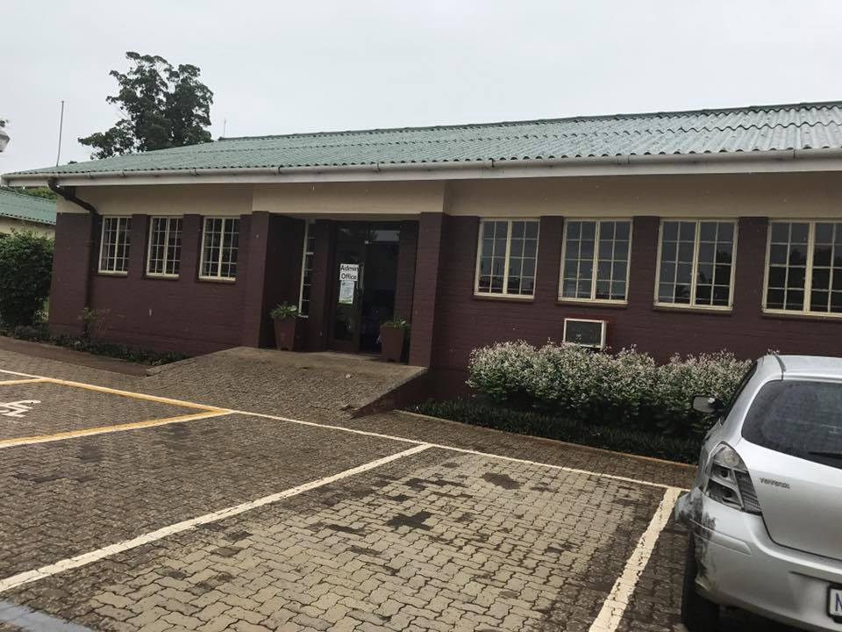

Many of the church activities I have attended have been events and retreats for the women and the youth of our local congregations. These can be anywhere from just a few hours long, to a whole week retreat. Together with the youth, young adults, and women of the church, we’ve done service projects, prayer nights, worship services, bible studies, sports days, games, and eaten lots and lots of food together. The church is a huge part of the community here, and they have taken such good care of me since I’ve gotten here.

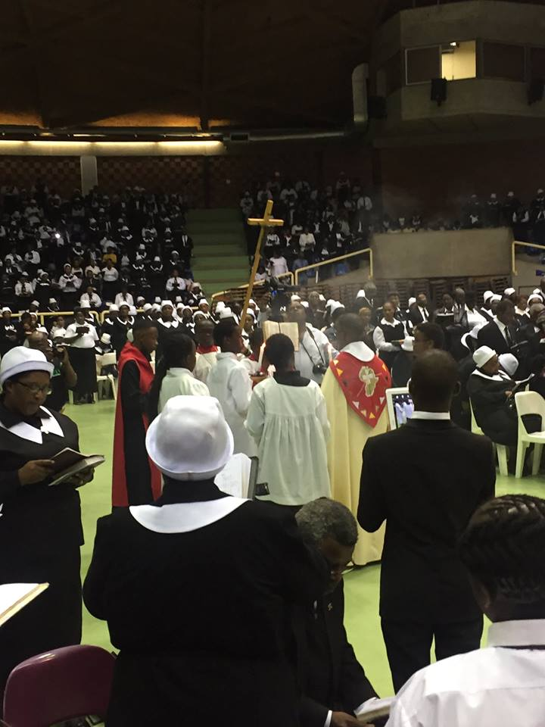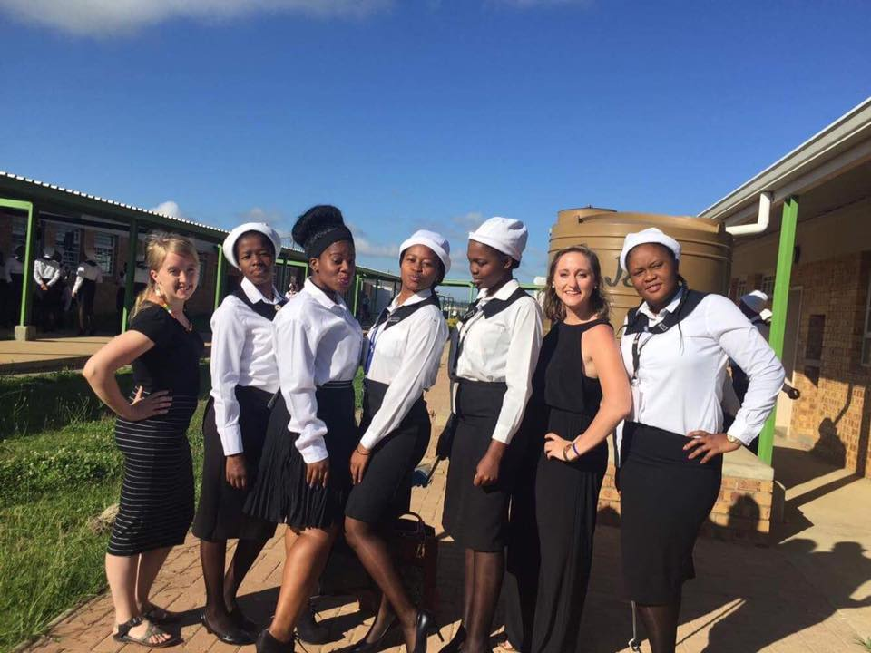

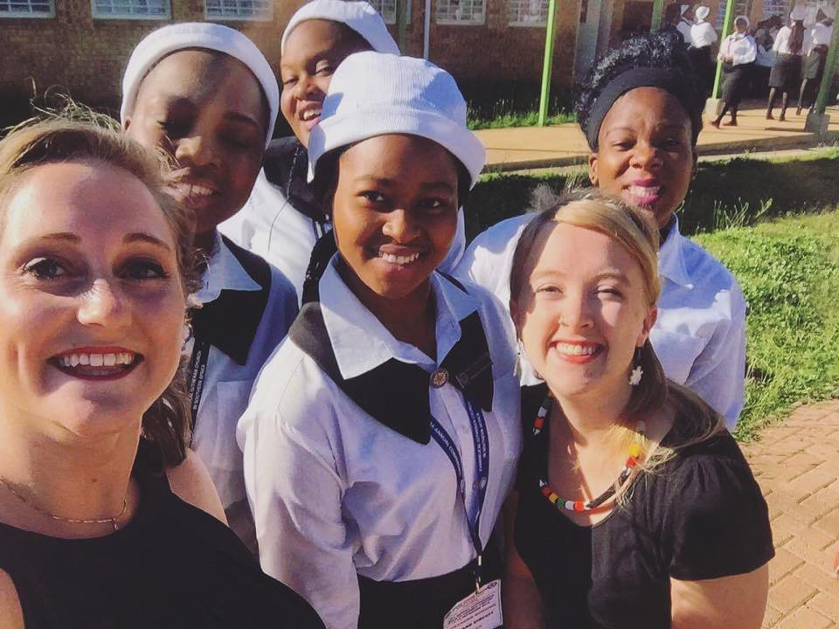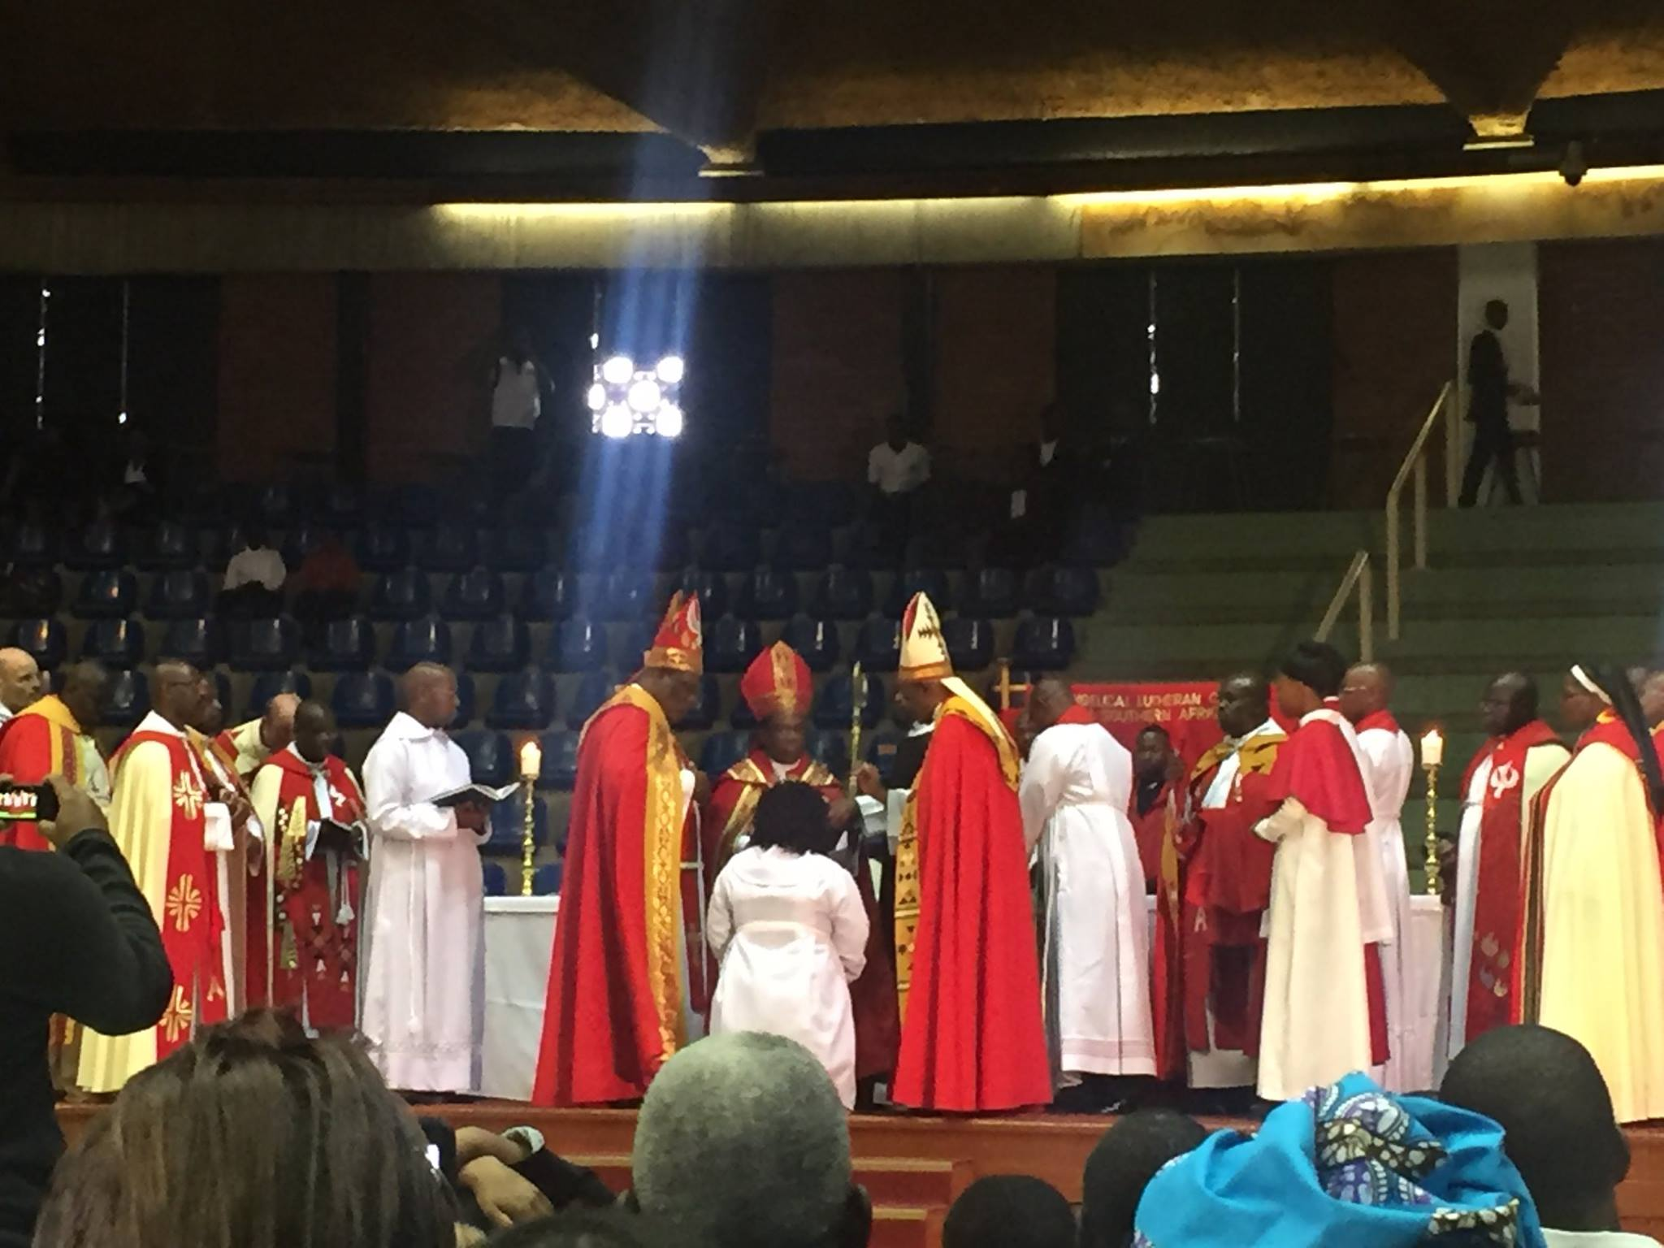

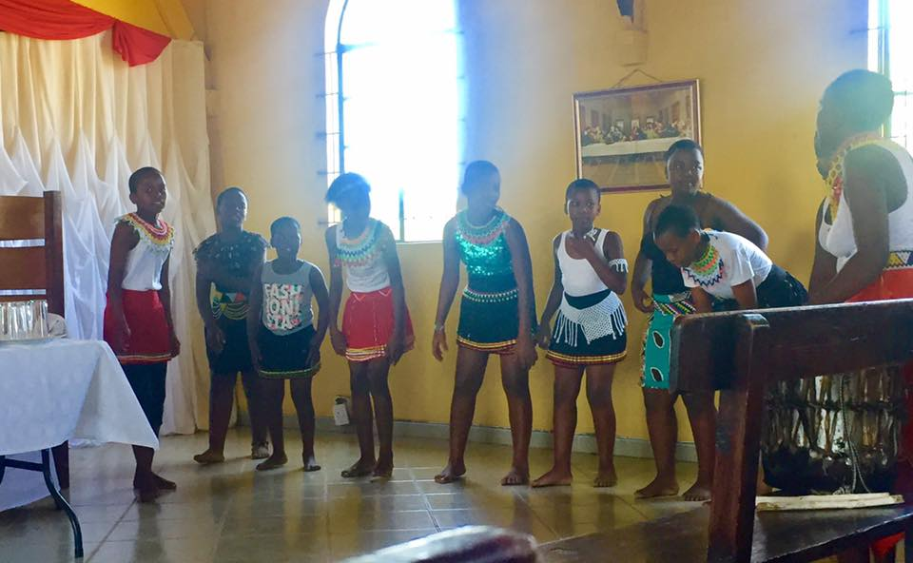
I’ve loved to meet and spend time with all of the strong women of our congregations. With Mbali, my host mom, who is busier, stronger, feistier, and funnier than almost anyone I’ve ever met. With my Gogo (grandmother), Mama Mngoma, who runs the church, raises her grandchildren, and graciously drives me to and from work each day. With Mama Khnize, who is the deputy mayor of our municipality and still finds the time to dance down the aisles to give her offering each Sunday. With Nozipho, who has had me over to her house on countless weekends and many dinners to spend time with her family, swim at the beach, watch movies, attend weddings, and tells me powerful stories of her childhood. These women inspire me to be strong and love harder each and every day.

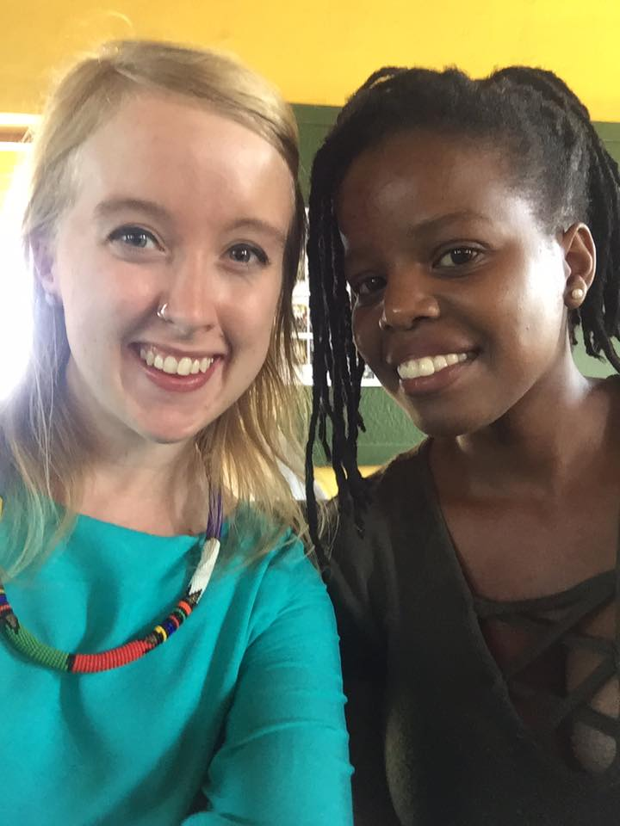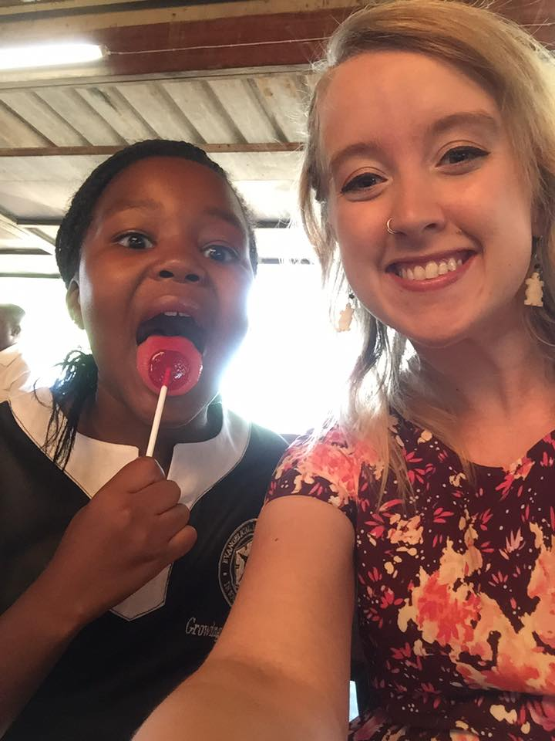

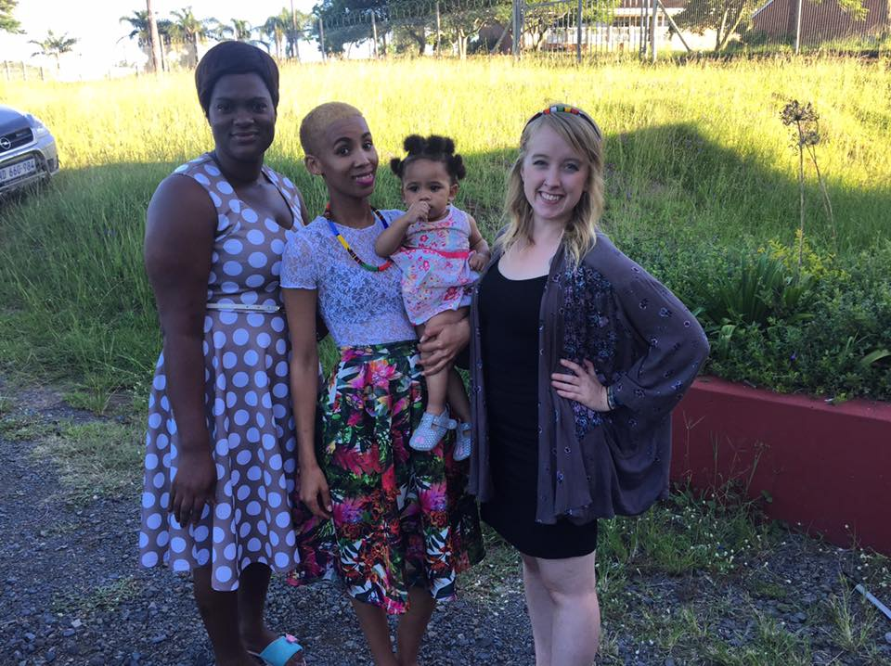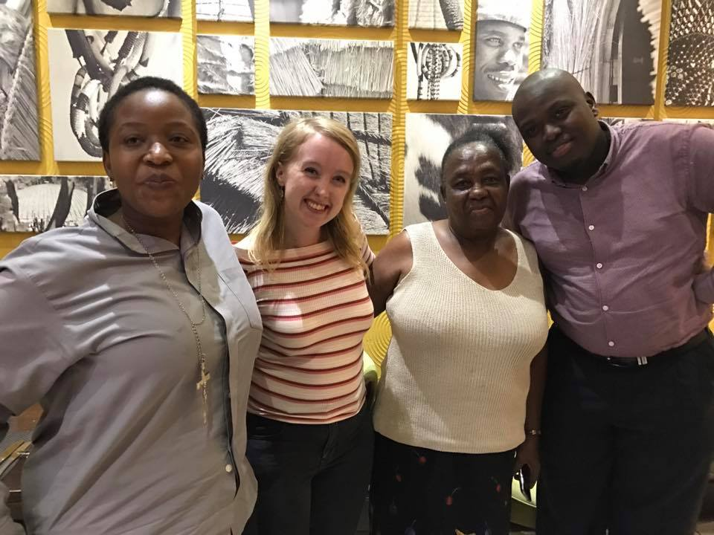

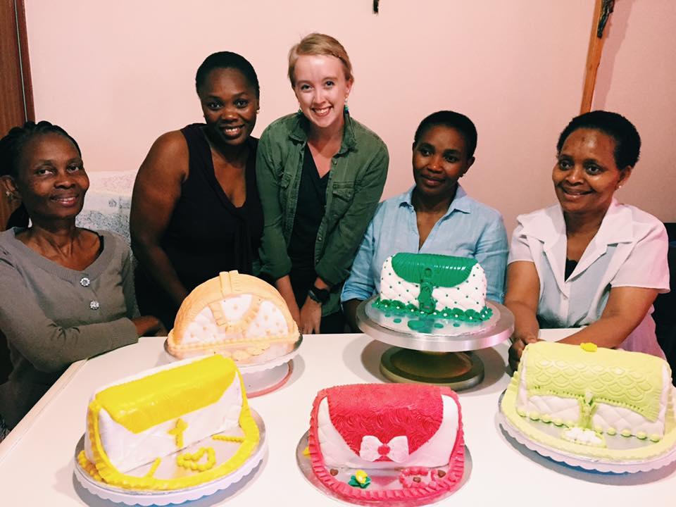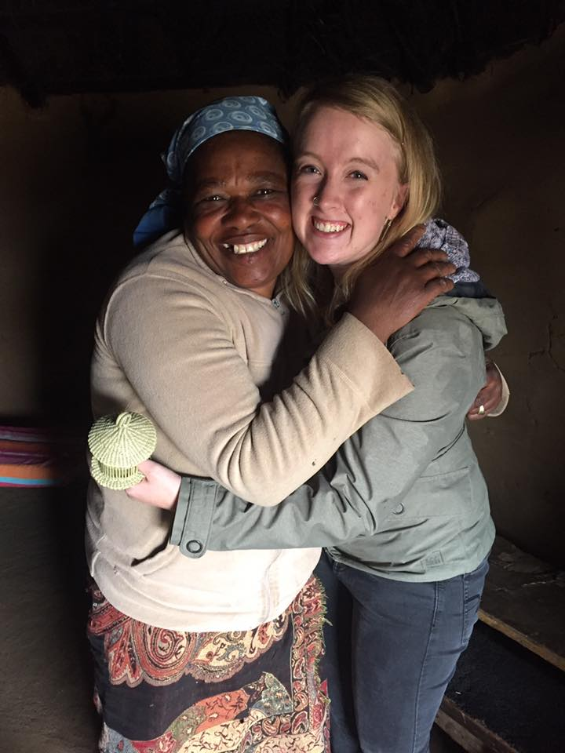

Through my year, I’ve also gotten to spend time with the numerous other YAGM volunteers in the country. I’ve traveled to four different provinces, spent a day in Lesotho, a week in Cape Town, and camped in the Kalahari Desert. I was lucky enough to have my parents, and Aunt and Uncle visit me for the week. I’ve been on safaris, hiked up mountains, swam in two oceans, met some wild South African penguins, and saw a Lion in his natural habitat. I’ve danced to traditional music, eaten cow tongue and chicken feet, drank gallons of Rooibos tea, named the geckos that live on my walls, and gotten stuck in traffic behind all the cows on the road. I’ve made lifelong friends, found family in a new home, saw God through new eyes, and heard voices full of power and beauty. I’ve seen unimaginable pain, learned the meaning of strength, and experienced impossible grace and forgiveness. I’ve spent a year in the Rainbow Nation.

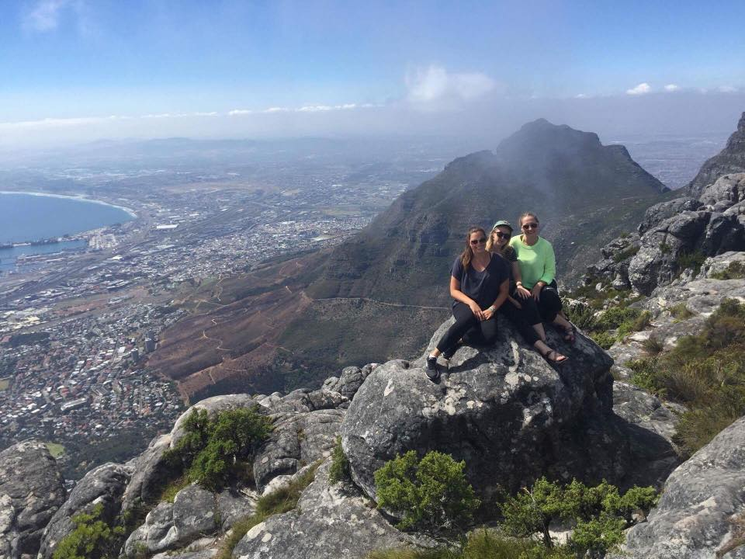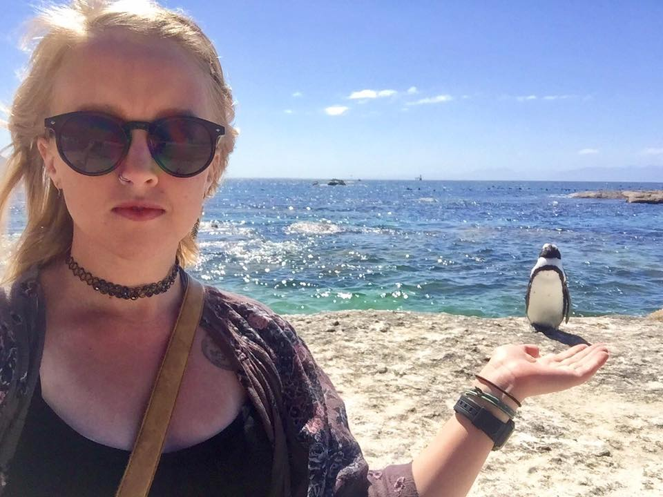

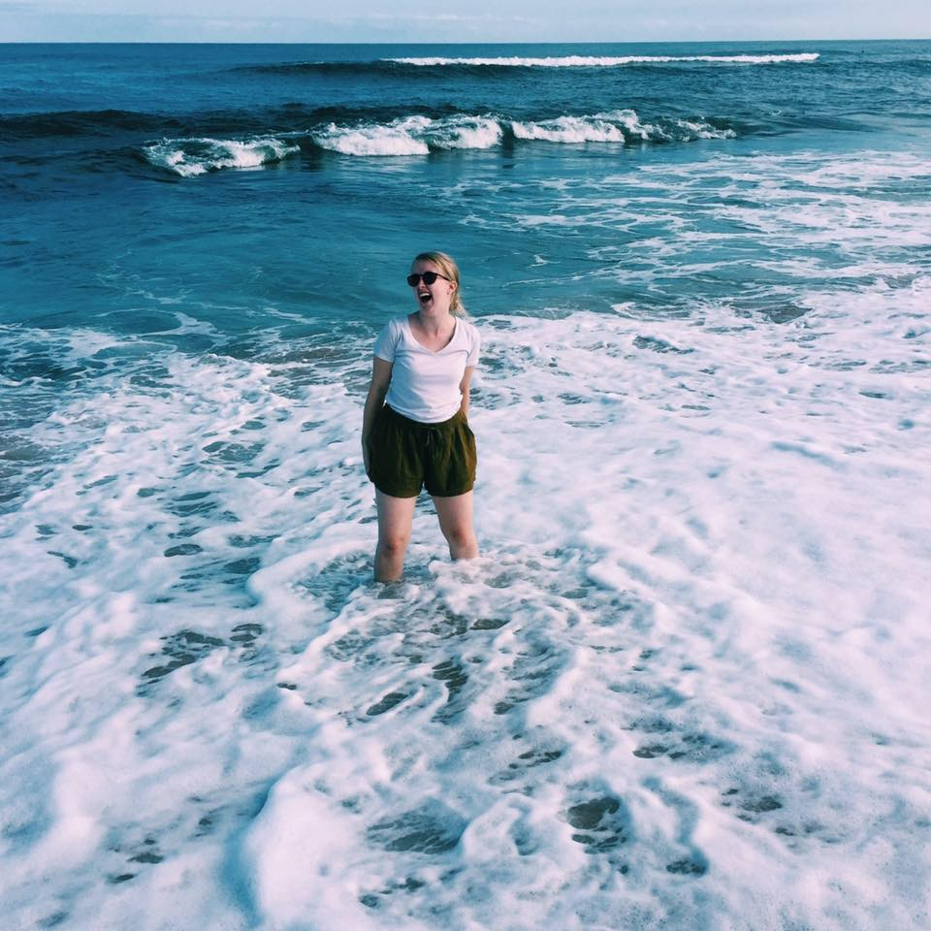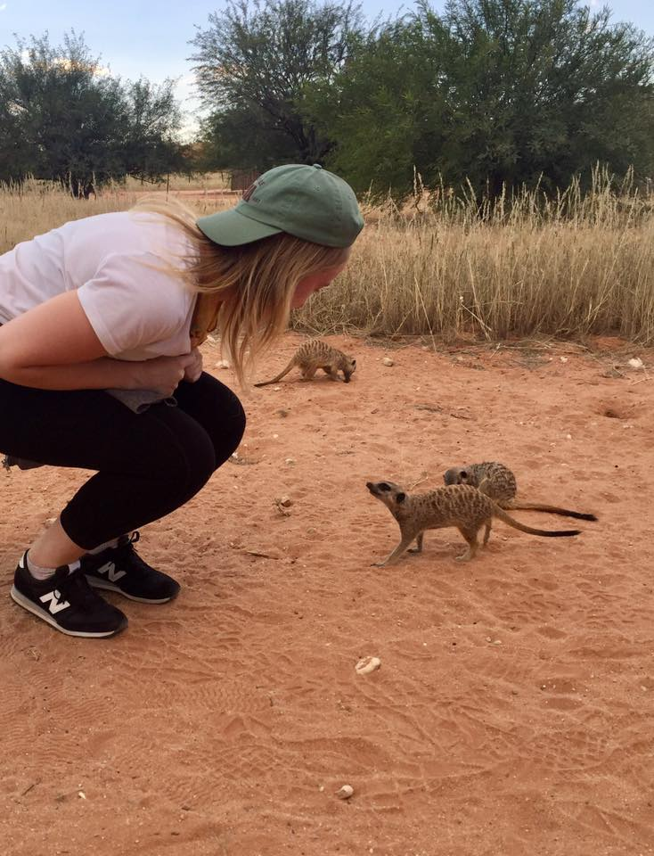

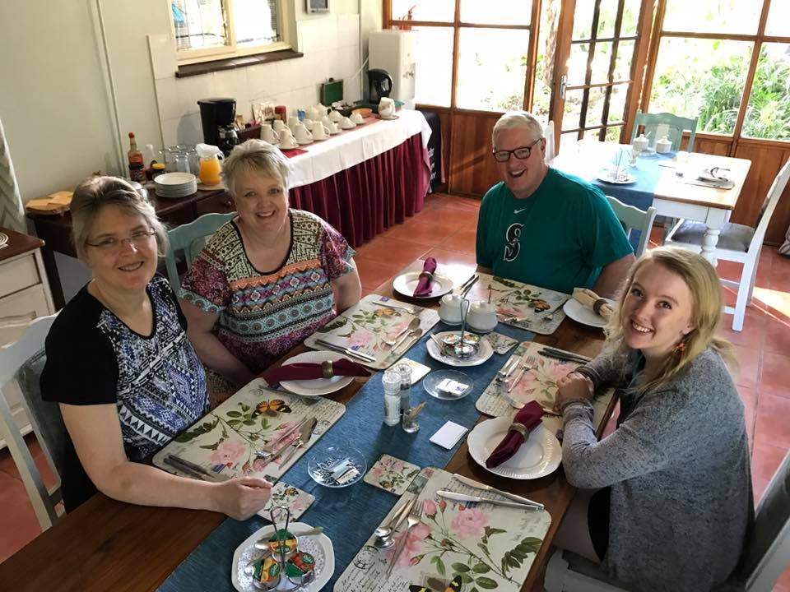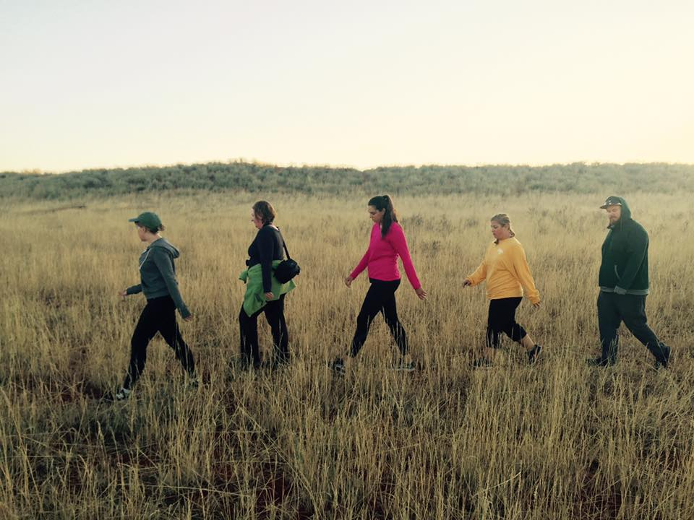
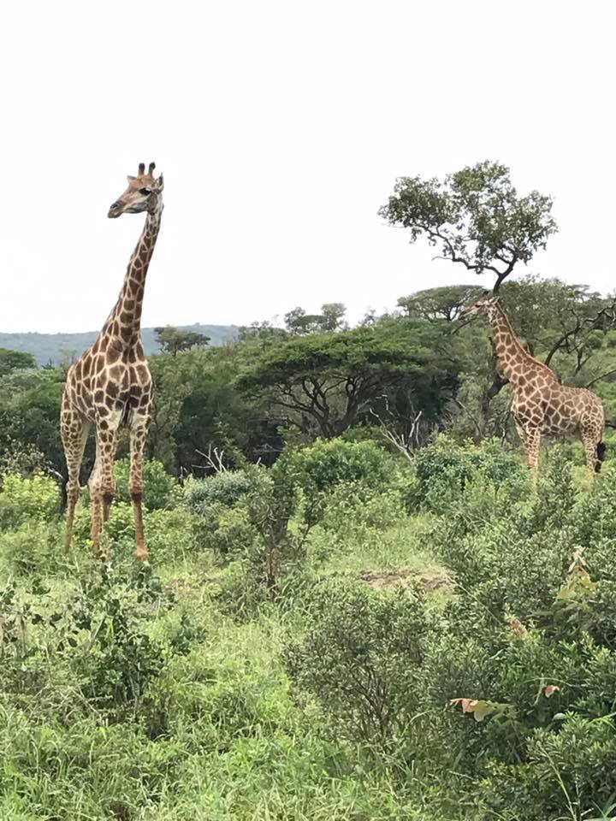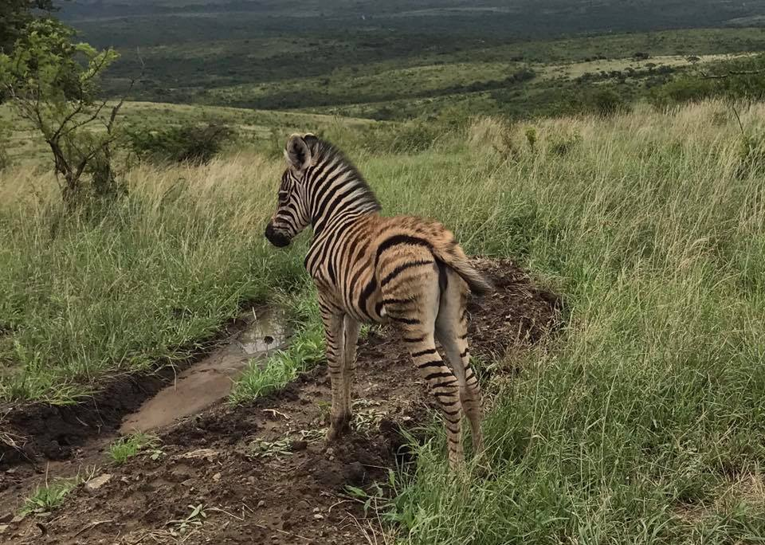

As always, I thank you all for your support and prayers in this journey of mine. This year has been a truly life changing experience, and I cannot believe I only have two months left! Sending love and hugs your way. Thank you!

